Practical 9

Aim: Implement an application for Worker Thread

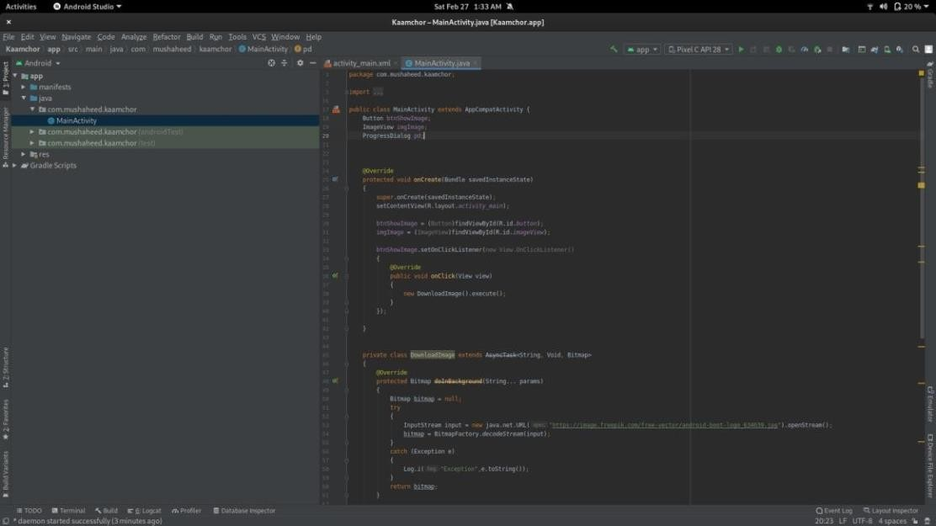FILE: src/main/java/com/example/kaamchor/MainActivity.java

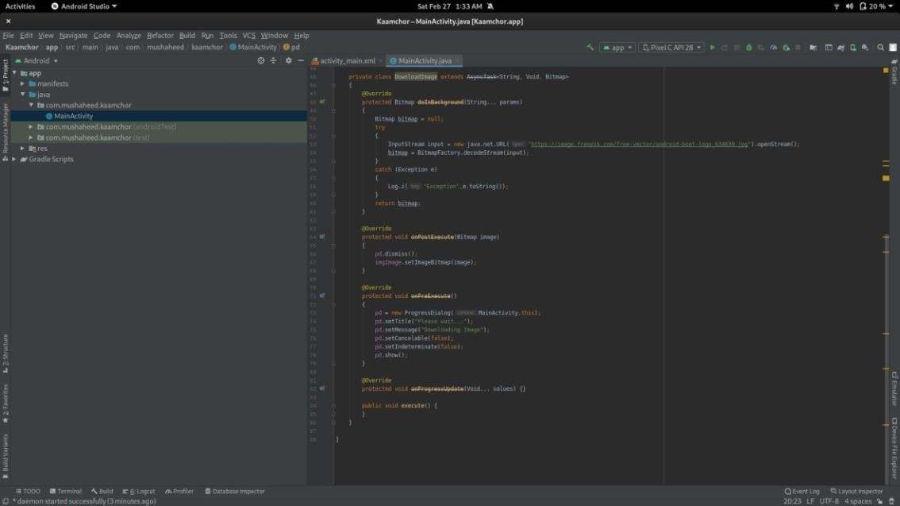

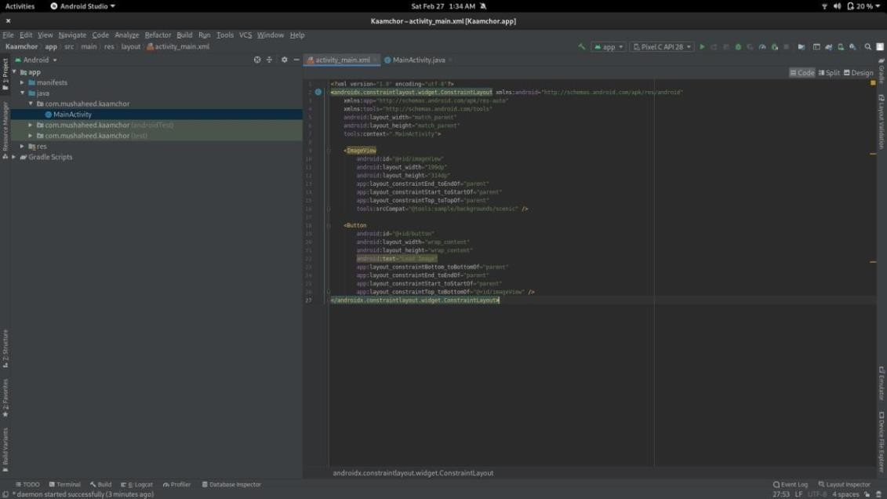FILE: src/main/res/layout/activity_main.xml

**Practical 10**

Aim: Implement an application for GPS

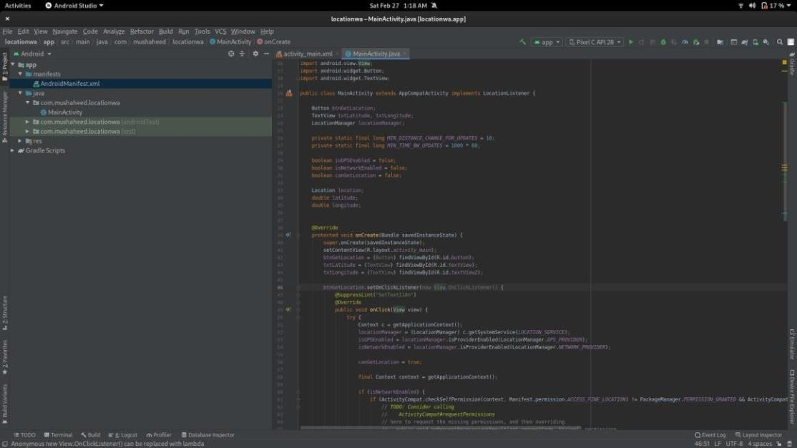File: src/main/java/com/example/location/MainActivity.java

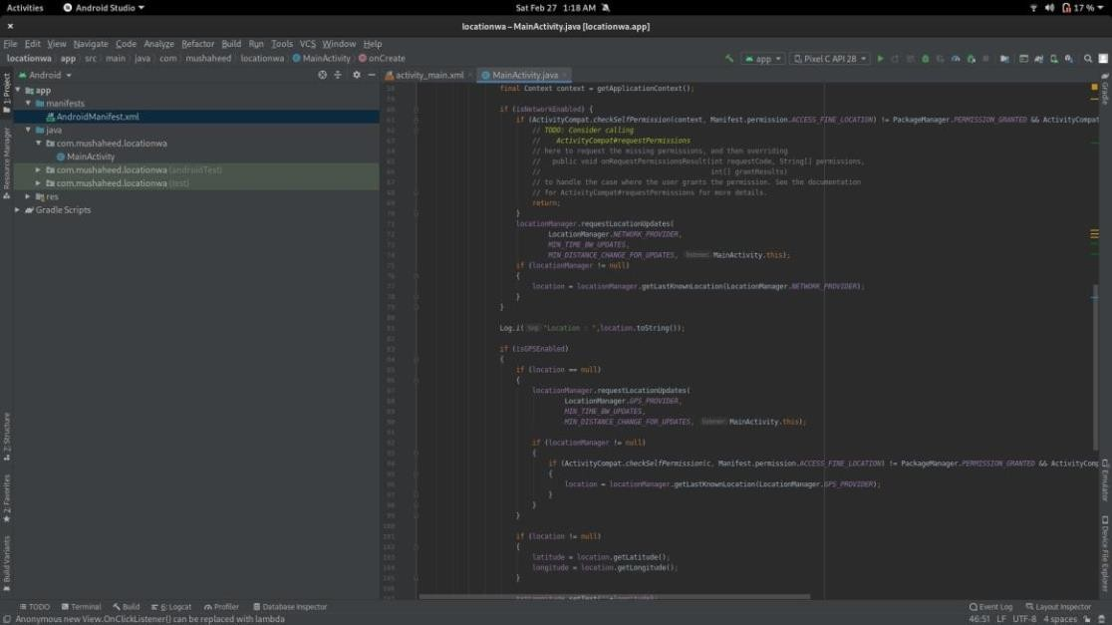

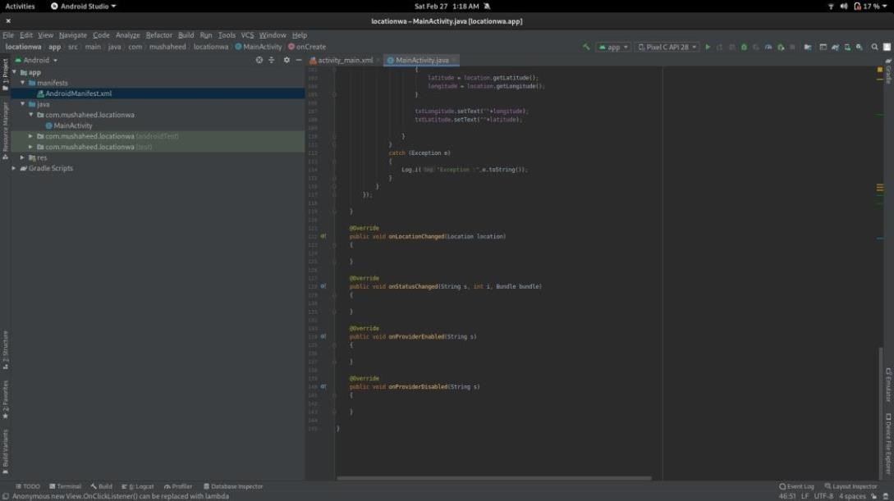

FILE: src/main/res/layout/activity_main.xml

